
2025/2026
Lab 5: Recursion, Linked List Queue & Deque

FAKULTI SAINS KOMPUTER DAN MATEMATIK
DATA STRUCTURE & ALGORITHM

VERSION 1
STUDENT INFORMATION

Please fill in your details:
Name: Click or tap here to enter text.
MATRIC NUMBER:Click or tap here to enter text.
GROUP:Click or tap here to enter text.
LAB: Choose an item.
DATE:Click or tap to enter a date.
Table of Contents
INSTRUCTIONS 1
TASK 1: Apply And Test The Implementation Of Recursion 2
TASK 2: Implementing Queue Using Linked List 5
TASK 3: Using DEQUE Built-In Class 10
TASK 4: Programming Assignment Using Deque 12

INSTRUCTIONS

Manual makmal ini adalah untuk kegunaan pelajar-pelajar Fakulti Teknologi Kejuruteraan Kelautan dan Informatik, Universiti Malaysia Terengganu (UMT) sahaja. Tidak dibenarkan mencetak dan mengedar manual ini tanpa kebenaran rasmi daripada penulis.
Sila ikuti langkah demi langkah sebagaimana yang dinyatakan di dalam manual.

This laboratory manual is for use by the students of the Faculty of Ocean Engineering Technology and Informatics, Universiti Malaysia Terengganu (UMT) only. It is not permissible to print and distribute this manual without the official authorisation of the author.
Please follow step by step, as described in the manual.

TASK 1: Apply and test the implementation of recursion

Objective
In this task, students must be able to:
- Apply the implementation recursion.
- Test the implementation

Estimated Time
[45 Minutes]

definition of recursion
Recursion is a basic programming technique you can use in Java, in which a method calls itself to solve some problem. A method that uses this technique is recursive. Many programming problems can be solved only by recursion, and some problems that can be solved by other techniques are better solved by recursion.
One of the classic problems for introducing recursion is calculating the factorial of an integer. The factorial of any given integer — call it n so that you sound mathematical — is the product of all the integers from 1 to n. Thus, the factorial of 4 is 24: 4 x 3 x 2 x 1.
The recursive way to look at the factorial problem is to realize that the factorial for any given number n is equal to n times the factorial of n–1, provided that n is greater than 1. If n is 1, the factorial of n is 1.
This definition of factorial is recursive because the definition includes the factorial method itself. It also includes the most important part of any recursive method: an end condition. The end condition indicates when the recursive method should stop calling itself. In this case, when n is 1, it just returns 1. Without an end condition, the recursive method keeps calling itself forever.
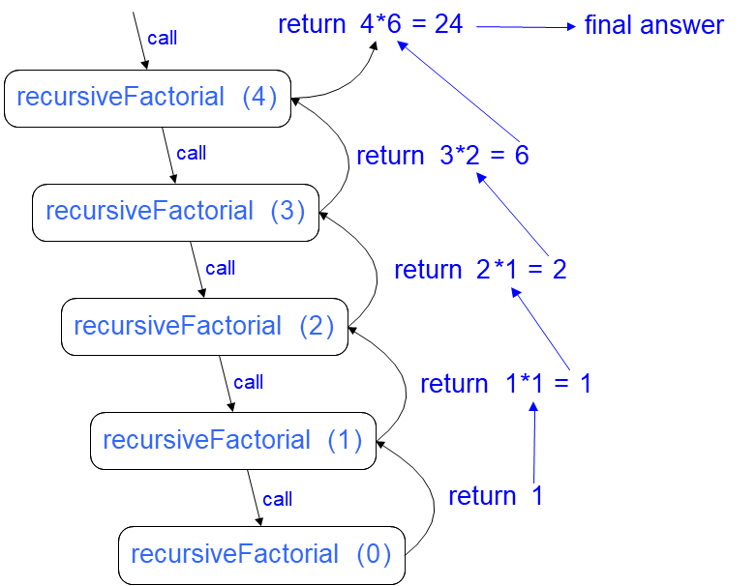
Figure 1: Recursion Trace for the factorial of 4

steps:
- Open Netbeans and create new java application project.
- Name your project as RecursionExperiment and click finish.
- Change author profiles to :
  - Name :
  - Program: <put your program. E.g., SMSK(SE) or SMSK with IM
  - Course : CSF3104
  - Lab : <enter lab number>
  - Date : <enter lab date>
- In the same RecursionExperiment project’s package, create a new file named Factorial.java and insert the following codes:
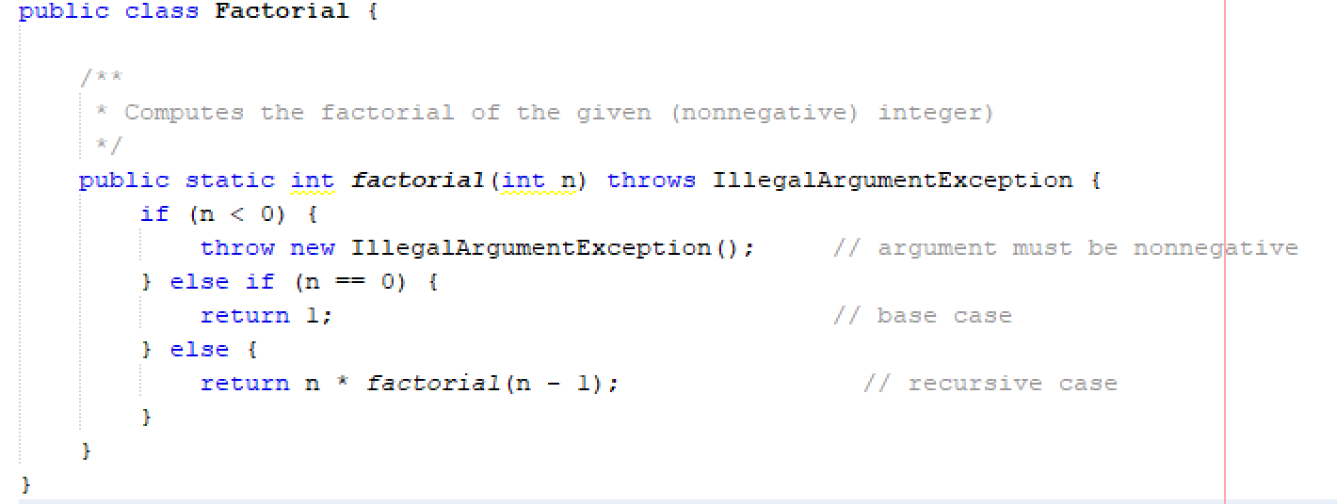
- Insert a main method in the same file to test the above codes. Put 6 as your input.
Answer:
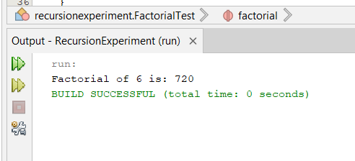

- Draw a recursion trace for an execution of your input.
Hint: You may draw using Ms Word/Ms Paint or draw it manually. Snap the photo of your drawing and upload it here.


questions
- Where can we apply recursion in data structure?
Answer:
Recursion can be applied in many data structures like trees, linked list, trees and sorting algorithms or any recursive data structures that has nested lists

- Explain what is the meaning of ‘base case’ and ‘recursive call’. What will happen when there is no base case in our recursive method?
Answer:
The condition that stops the recursion.

TASK 2: implementing queue using linked list

objective
In this task, students will implement a queue using linked list as an alternative to array.

estimated time
[45 Minutes]

using linked list for queue
A queue is a First In First Out (FIFO) data structure where the first item inserted is the first to be removed. In a queue items are inserted at the rear and removed from the front of the queue.
Following image shows an implementation of Queue as linked list with front and rear references.
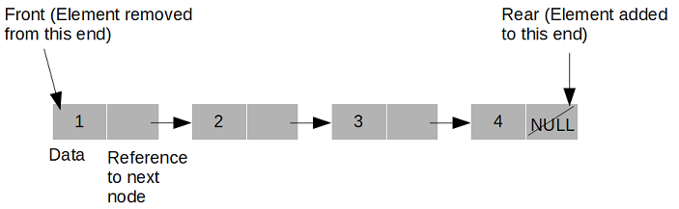

operations in queue
As we know, there are three operations are implemented for a Queue:
insert: To insert an item at the rear of the queue.
remove: To remove an item from the front of the queue.
peek: Read value from the front of the queue without removing it.

steps:
- Open Netbeans and create new java application project.
- Name your project as LinkedListQExperiment and click finish.
- Change author profiles to :
  - Name :
  - Program: <put your program. E.g., SMSK(SE) or SMSK with IM
  - Course : CSF3104
  - Lab : <enter lab number>
  - Date : <enter lab date>

- In the same LinkedListQExperiment project’s package, create a new file named LinkedListQueue.java and insert the following codes:
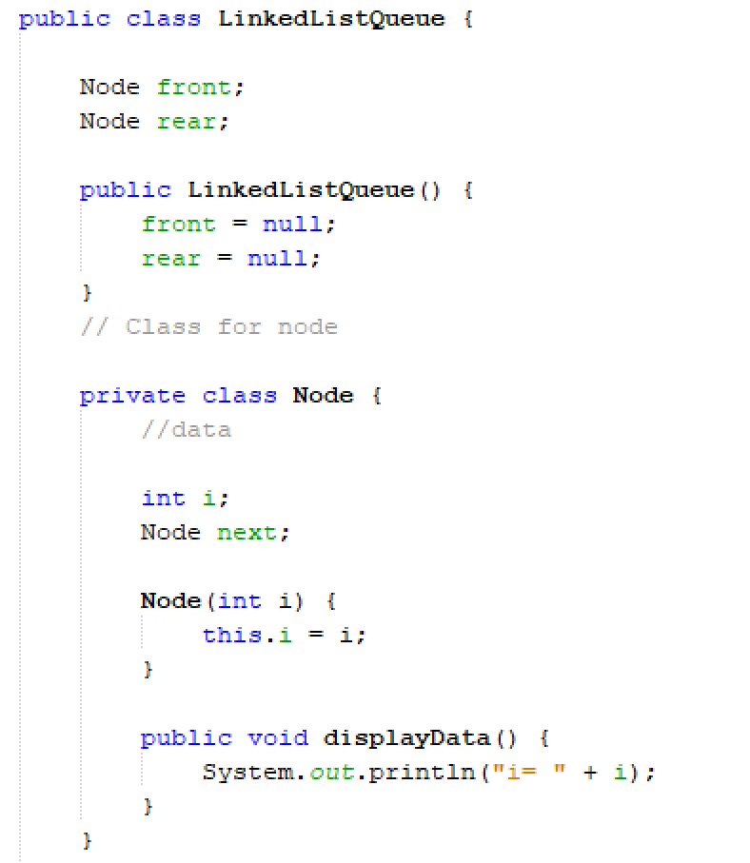
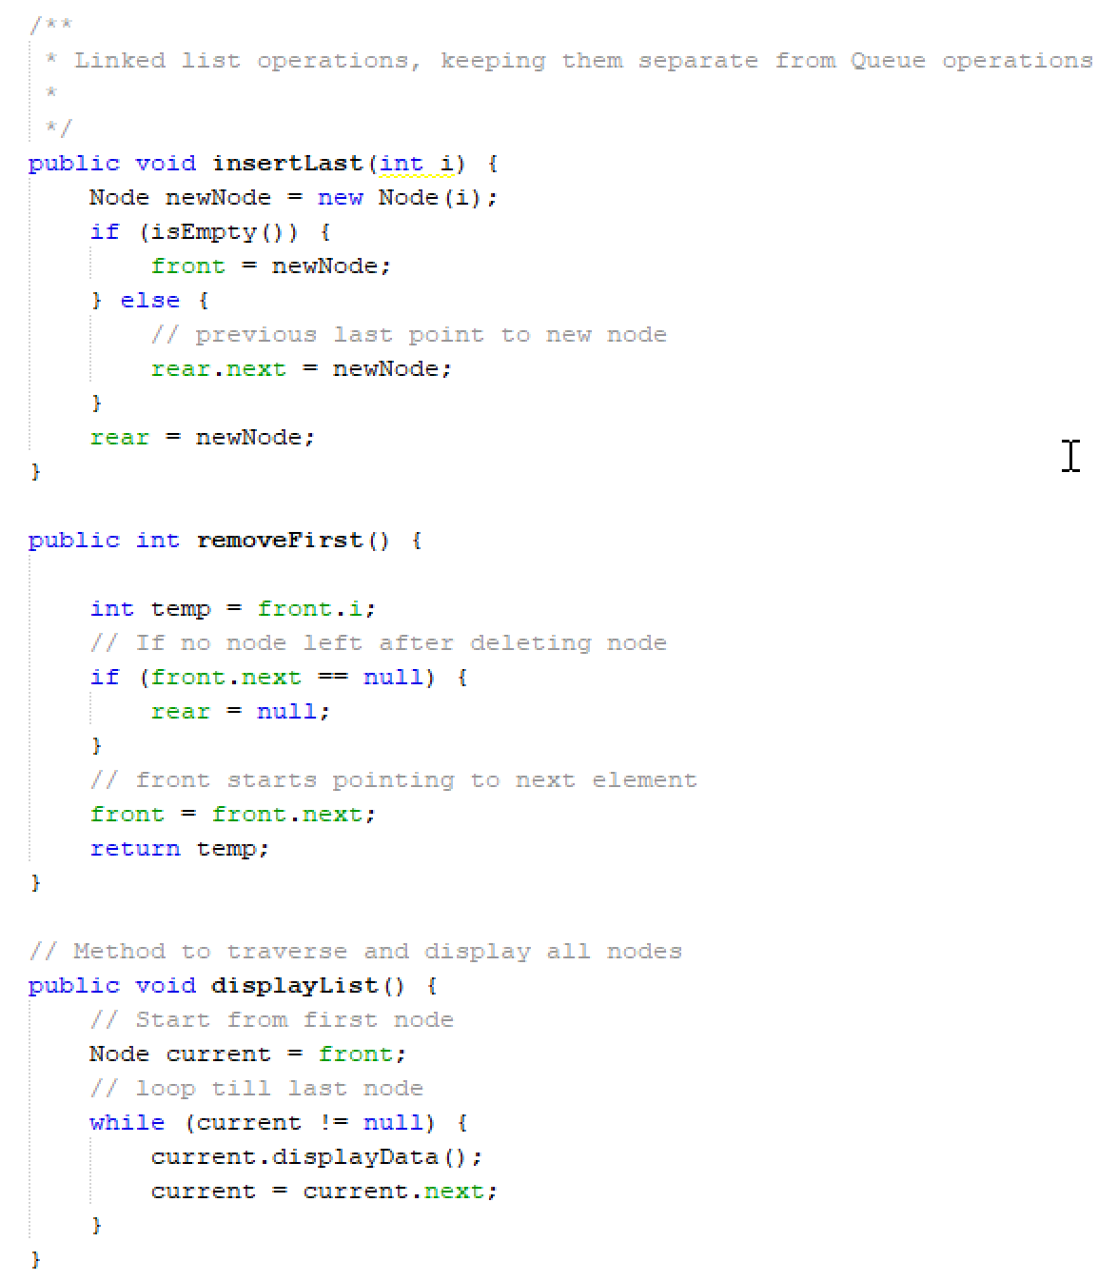
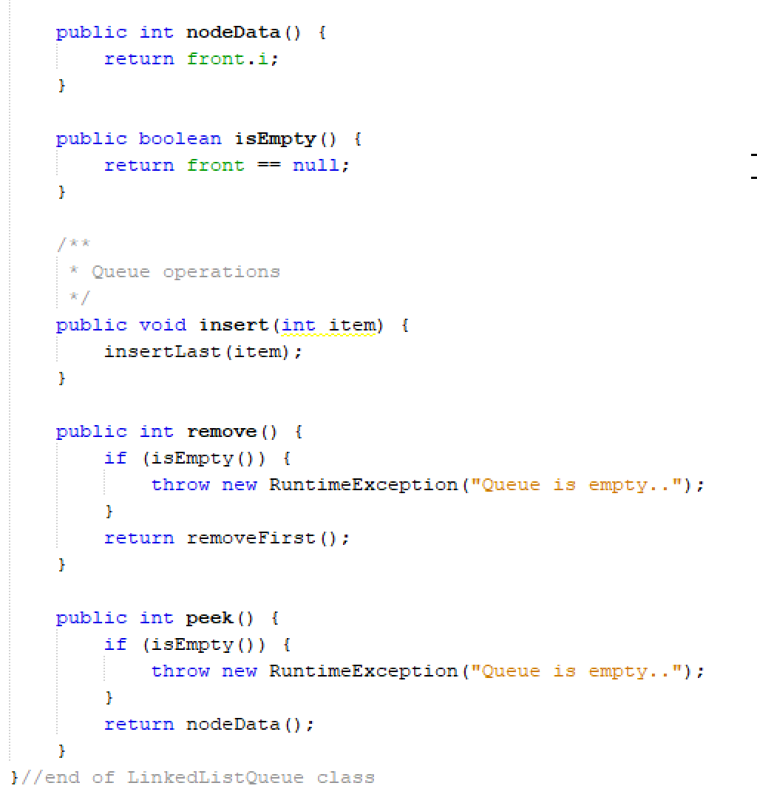
- Create a test class for the LinkedListQueue. Use 2,1,0,3,0 as your input. Sample output:
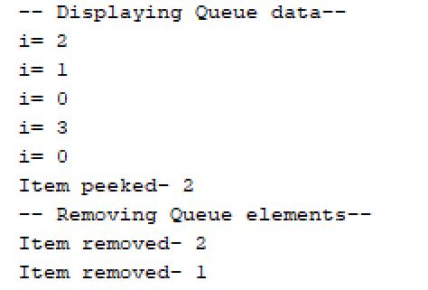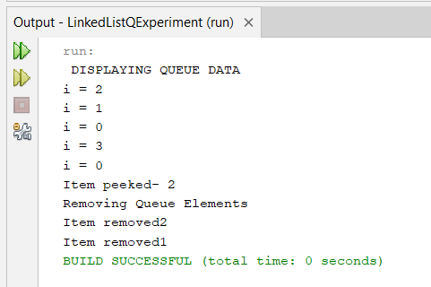
- Copy and paste your Java codes into text box below:
package linkedlistqexperiment;

/**
*
* @author user
*/
public class LinkedListQ {

Node front;
Node rear;

public LinkedListQ(){
front = null;
rear = null;
}

private class Node {
int i;
Node next;

Node(int i) {
this.i = i;
}

public void displayData(){
System.out.println("i = " +i);
}
}

// linked list operations, keeping them seperate from Queue operations

public void insertLast(int i){
Node newNode = new Node(i);
if (isEmpty()){
front = newNode;
}else{
rear.next = newNode;
}
rear = newNode;
}
public int removeFirst(){
int temp = front.i;
// if no node left after deleting node
if (front.next == null){
rear = null;
}
// front starts pointing to next element
front = front.next;
return temp;

}
// method to transverse and display all nodes
public void displayList(){
//start from first node
Node current = front;
//loop till last node
while (current != null){
current.displayData();
current = current.next;
}
}

public int nodeData(){
return front.i;
}
public boolean isEmpty(){
return front == null;
}
//queue operations
public void insert(int item){
insertLast(item);
}
public int remove(){
if (isEmpty()){
throw new RuntimeException("Queue is empty..");
}
return removeFirst();
}
public int peek(){
if (isEmpty()){
throw new RuntimeException("Queue is empty..");
}
return nodeData();
}
}

package linkedlistqexperiment;

/**
*
* @author user
*/
public class LinkedListQueueTest {

public static void main(String[] args) {
LinkedListQ queue = new LinkedListQ();

//insert elements: 2,1,0,3,0
int[] inputs ={2, 1, 0, 3,0};

System.out.println(" DISPLAYING QUEUE DATA");
for (int i : inputs){
queue.insert(i);
}
queue.displayList();

//peek
System.out.println("Item peeked- "+ queue.peek());

System.out.println("Removing Queue Elements");
//remoce first 2 elements
System.out.println("Item removed" + queue.remove());
System.out.println("Item removed" + queue.remove());
}
}

questions
- Describe the advantage(s) of using linked list for queue compared to array.
Answer:
Dynamix size,no wasted memory, efficient enqueue and dequeue, better memory use.

- Where can we apply queue in the software development?
Answer:
Task Scheduling , web servers, undo\ redo operations, batch processing

TASK 3: using DEQUE built-in class

objective
During this activity, students will apply double-ended queue (deque) in a simple programming task. Student should understand how deque works.

estimated time
[30 Minutes]

Introduction
Java Deque Interface is a linear collection that supports element insertion and removal at both ends. Deque is an acronym for "double ended queue".

steps:
- Open previously created Netbeans project.
- Create a new class named DequeDemo.
- In DequeDemo.java, import Deque and ArrayDeque class from java.util package:
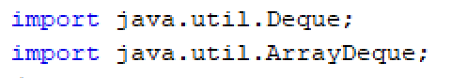
- Type the following codes into your Netbeans editor:
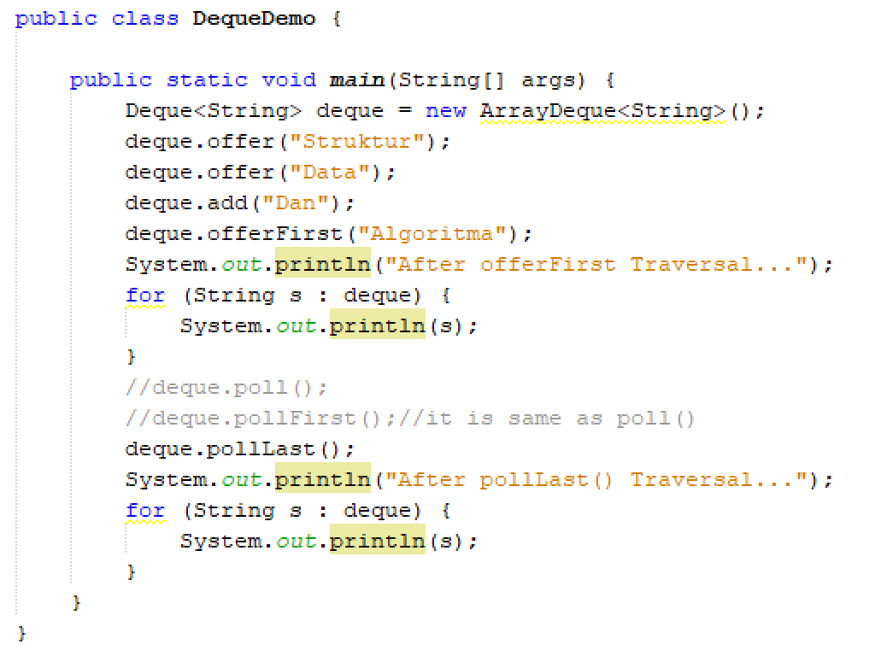
- Save, compile and run the codes. Observe the output and explain how the below methods work:
  - offer()
  - add()
  - offerFirst()
  - pollLast()
Answer:
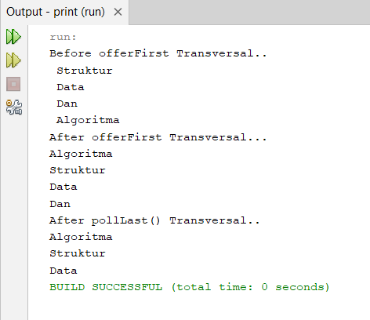
Before offerFirst Transversal..
Struktur
Data
Dan
Algoritma
After offerFirst Transversal...
Algoritma
Struktur
Data
Dan
After pollLast() Transversal..
Algoritma
Struktur
Data

questions
- Explain the difference between linear queue and double-ended queue.
Answer:
Linear que follows FIFO (First-In-First-Out) principle and double-ended queue allows insertion and deletion from both ends

TASK 4: Programming assignment using deque

objective
To implement a PhoneBook class and create a simple program to save and retrieve a Phone Book records.

estimated time
[30 Minutes]

Instructions:
Given here is the structure of a class named PhoneBook:
PhoneBook
id: int
name: String
phoneNumber: String
- Implement the above class using Java. Create a parameterized constructor that accepts three parameters, as described in the PhoneBook class diagram.
- Next, create a demo class to insert and traverse records in the PhoneBook. Use Deque and ArrayQueue in your implementation.
- Use the following dataset to test your program:
  - Pendaftar UMT: 096684342
  - Jabatan Pengurusan Akademi UMT: 096684219
  - Fakulti Teknologi Kejuruteraan Kelautan dan Informatik: 096683220
- Bonus task: Create a search function to retrieve a record from your PhoneBook program. As example, user enters “Pendaftar” as an input, and then your program will display “096684342” as the output.
- Copy and paste your finished codes into the below text box:
PhoneBook.java
public class PhoneBook {
private int id;
private String name;
private String phoneNumber;

// Parameterized constructor
public PhoneBook(int id, String name, String phoneNumber) {
this.id = id;
this.name = name;
this.phoneNumber = phoneNumber;
}

// Getters
public int getId() {
return id;
}

public String getName() {
return name;
}

public String getPhoneNumber() {
return phoneNumber;
}

// Display method
public void displayRecord() {
System.out.println("ID: " + id + ", Name: " + name + ", Phone: " + phoneNumber);
}

@Override
public String toString() {
return "ID: " + id + ", Name: " + name + ", Phone: " + phoneNumber;
}
}

PhoneBookDemo.java
import java.util.ArrayDeque;
import java.util.Deque;

public class PhoneBookDemo {
public static void main(String[] args) {
// Using Deque (as both stack and queue)
Deque<PhoneBook> phoneDeque = new ArrayDeque<>();

// Using ArrayDeque as a regular queue
ArrayDeque<PhoneBook> phoneQueue = new ArrayDeque<>();

// Insert records into both data structures
PhoneBook record1 = new PhoneBook(1, "Pendaftar UMT", "096684342");
PhoneBook record2 = new PhoneBook(2, "Jabatan Pengurusan Akademi UMT", "096684219");
PhoneBook record3 = new PhoneBook(3, "Fakulti Teknologi Kejuruteraan Kelautan dan Informatik", "096683220");

// Add to deque (as stack - LIFO)
phoneDeque.push(record1);
phoneDeque.push(record2);
phoneDeque.push(record3);

// Add to queue (FIFO)
phoneQueue.add(record1);
phoneQueue.add(record2);
phoneQueue.add(record3);

// Display records from Deque
System.out.println("=== DEQUE RECORDS (LIFO) ===");
for (PhoneBook record : phoneDeque) {
System.out.println("ID: " + record.getId() + ", Name: " + record.getName() + ", Phone: " + record.getPhoneNumber());
}

// Display records from Queue
System.out.println("\n=== QUEUE RECORDS (FIFO) ===");
for (PhoneBook record : phoneQueue) {
System.out.println("ID: " + record.getId() + ", Name: " + record.getName() + ", Phone: " + record.getPhoneNumber());
}

// === BONUS TASK: SEARCH FUNCTION ===
System.out.println("\n=== BONUS: SEARCH FUNCTION ===");
searchPhoneNumber(phoneDeque, "Pendaftar"); // Example: user enters "Pendaftar"
}

// BONUS: Search function to retrieve record by name
public static void searchPhoneNumber(Deque<PhoneBook> phoneBook, String searchName) {
System.out.println("Searching for: '" + searchName + "'");

boolean found = false;
for (PhoneBook record : phoneBook) {
if (record.getName().toLowerCase().contains(searchName.toLowerCase())) {
System.out.println("MATCH FOUND: " + record.getPhoneNumber()); // Displays "096684342"
found = true;
break;
}
}

if (!found) {
System.out.println(" No records found for: " + searchName);
}
}
}
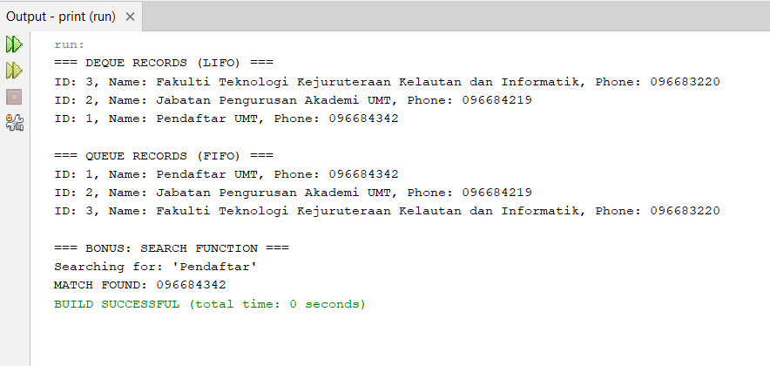

Finally, read the instruction regarding submission carefully. Submit your answer using the link provided in Oceania UMT. Please ensure your codes are submitted to the correct group.

